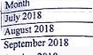

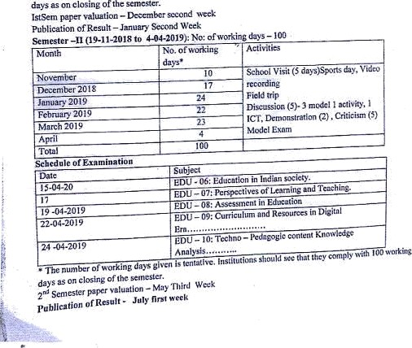gcaedale of inaaop
07-11-2018
'•e4•20l9
 | " , | Capac@ BuJJig Hegmmme , M€QTes .  W@Twig @ @it[ag DiWm]a (y),
' ®
21
iotas

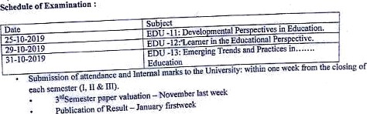
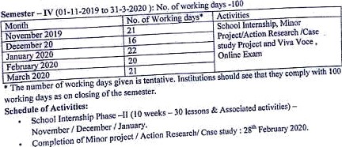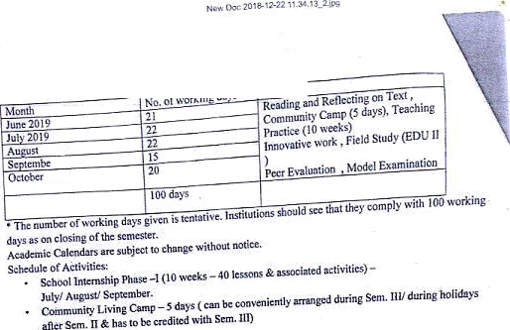
t9
t0j9io3

Plas -J£ irslha kofMaxfi 2020(Pj ct& flw =)
hD U - 14 , EDb• 1S - OningchminaionS:odlfof Mac 2020.

iblication of Result: I irsl half of Aprll 2020.

Sdn DrGbvG‹o• B•*

